**Project Design Phase-II**

**Technology Stack (Architecture & Stack)**

|  |  |
| --- | --- |
| Date | 24 October 2022 |
| Team ID | PNT2022TMID29109 |
| Project Name | Real-time communication system powered by AI for specially abled |
| Maximum Marks | 4 Marks |

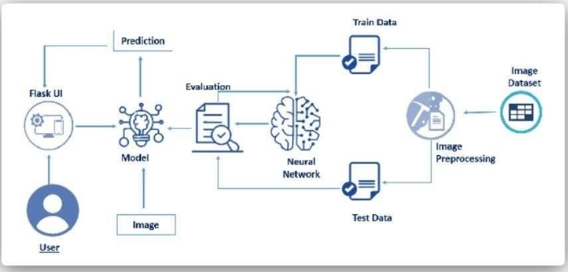

|  |  |  |  |
| --- | --- | --- | --- |
| **S.No** | **Component** | **Description** | **Technology** |
| 1. | User | Deaf-mute person unable to communicate with others leading to dependency and unsocial behaviour. | AI technology |
| 2. | Flask UI | Flask is a small and lightweight Python web framework that provides useful tools and features that make creating web applications in Python easier. | Python |
| 3. | Models | Support Vector Machine (SVM) is subsequently applied to classify our gesture image dataset. | Machine learning |
| 4. | Image | Images of various hand gestures are fed to be converted into speech through image processing system | ANN, CNN,  Open CV |
| 5. | Image  prediction | Images fed are observed and  predicted for the gestures | AI and neural network |
| 6. | Evaluated data | Aims to determine the accurate result for the image processed and predicted. | AI technology |
| 7. | Neural network | A neural network is a series of algorithms that endeavors to recognize underlying relationships in a set of data through a process that mimics the way the human brain operates. | AI technology |
| 8. | Test data | Samples used for comparison and formulating the result. | Cloud database |
| 9. | Train data | Samples as the output from the processed input | Neural network |
| 10. | Image pre processing | improvement of the image data that  suppresses unwilling distortions or enhances some image features important for further processing | AI technology |
| 11. | Image dataset | An image dataset includes digital images curated for testing, training, and evaluating the performance of machine learning and artificial intelligence (AI) algorithms, commonly computer vision algorithms. | Cloud database |